**2nd grade – language arts. 1st week.**

Students will have to punctuate some sentences correctly.

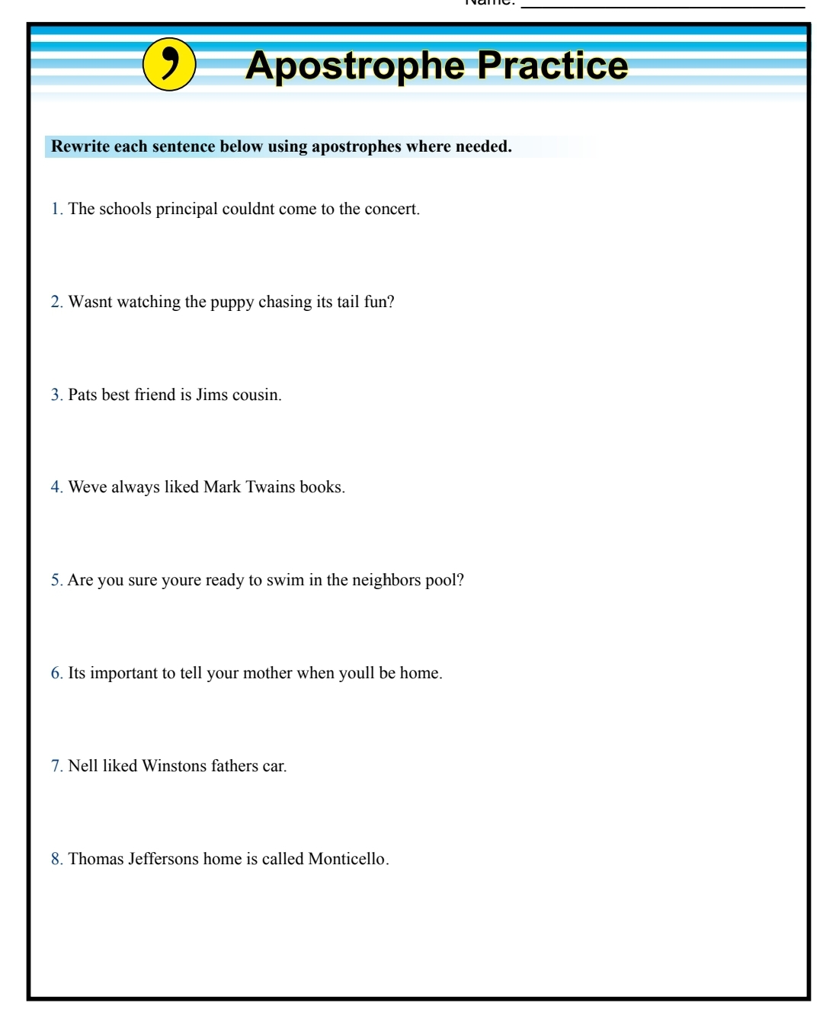

**Answer sheet.**

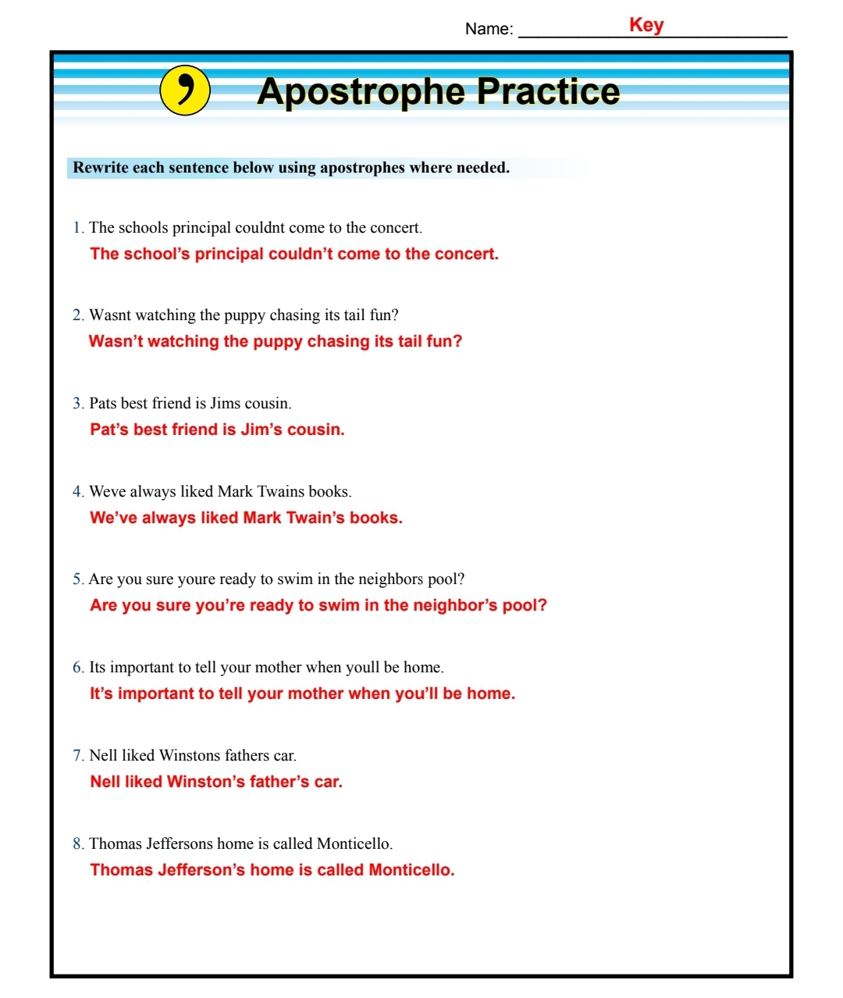

**2nd grade – language arts. 2nd week.**

Students will investigate what are the uses of **all, most, some, a lot of, none** and **a little.**

Students will create 2 sentences with each one of them.

Students will complete page 110 of the workbook.

**2nd grade – language arts. 3rd week.**

Students will investigate the use of **both (of the), neither** and **either.**

Create 2 sentences with each one of them.

Complete page 111 of the workbook.