**practice of Science 5th Grade**

**Miss Ana peña.**

**First week.**

**Complete the sentece using the words above.**

**Plant life cycles.**

**pollination, pollen, embryo, seed coat, germination, monocot, dicot and conifer. (remember that you have the vocabulary in your notebook)**

1. **Is the entire seed sorrounded by a tough outer covering_________________**
2. **Produces seed with a single cotyledon________________**
3. **Is a gymnosperm, a plant that has seeds but not flowers___________________________**
4. **Is the transfer of pollen___________________**
5. **Is the development of a seed into a new plant______________**
6. **Is the beginning of a new offspring________________________**
7. **Produces seeds with two cotyledons______________________**
8. **Is a yellow powder that contains sperm cells__________________________**

**Second week**

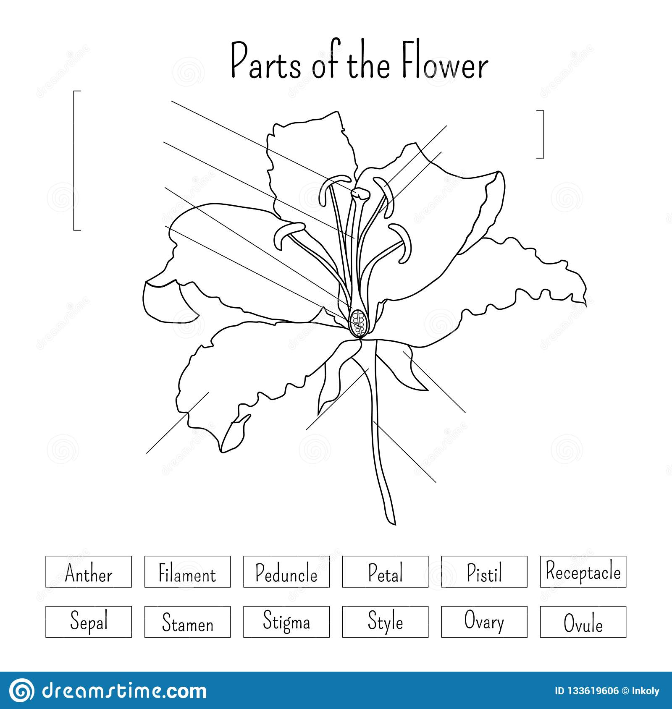

* **Remember that you have drawn a flower in your notebook, answer it as you can with your parents help.**
* **Recuerda que has dibujado una flor en tu cuaderno, responde como puedas con ayuda de tus padres.**

**Third week**

**Animal life cycle.**

**Select the correct answer.**

**1. Is an inmature stage that does not resemble the adult.**

1. **pupa b) Larva c) nymph**

**2. Is a series of distinct growth stages that are different from another one.**

1. **metamorphosis b) internal fertilization c) external fertilization**

**3. The egg and sperm outside the females body is called**

1. **internal fertilization b) external fertilization c) incomplete metamorphosis.**

**4. Is similar to an adult form, but it is smaller and lacks wings and reproductive structures.**

1. **Larva b) pupa c) nymph**

**II. Write the difference between complete and incomplete metamorphosis.**

**III. Write the difference between external fertilization and internal fertilization.**