**Practice of social studies**

**5th Grade**

**Miss Ana peña.**

**First week.**

**write the meaning of**

**Location**

_______________________________________________________________________________________________________________________________________________________________

**Place**

_______________________________________________________________________________________________________________________________________________________________

**region**

_______________________________________________________________________________________________________________________________________________________________

**Movement**

_______________________________________________________________________________________________________________________________________________________________

**Human interaction**

_______________________________________________________________________________________________________________________________________________________________

**Desert**

_______________________________________________________________________________________________________________________________________________________________

**Mountain**

__________________________________________________________________________________________________________

**Ocean**

_______________________________________________________________________________________________________________________________________________________________

**Volcano**

_______________________________________________________________________________________________________________________________________________________________

**Waterfall**

_______________________________________________________________________________________________________________________________________________________________

**River**

_______________________________________________________________________________________________________________________________________________________________

**Island**

___________________________________________________________________________________________________________________________________________________________________________

**Second week**

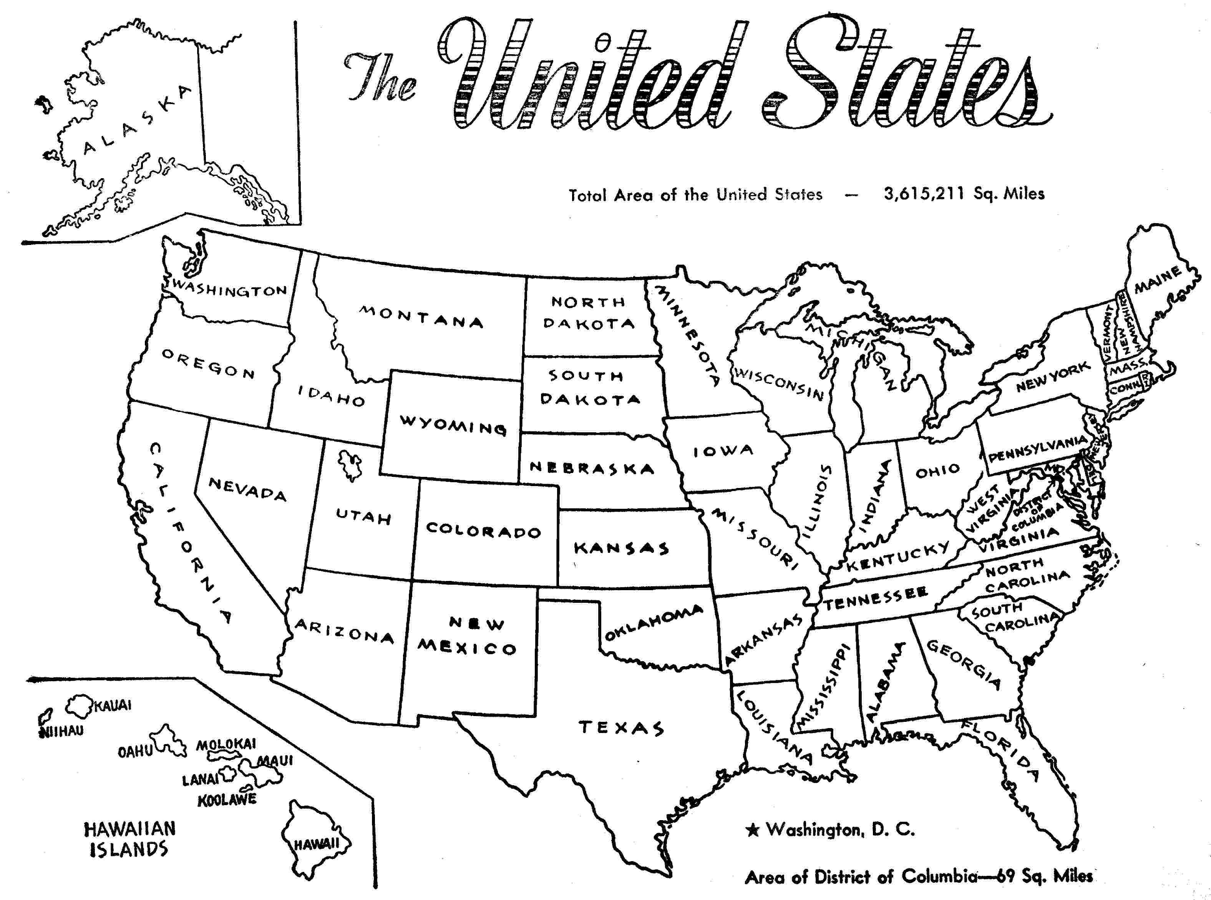

**Look at the map and then write the location of the city.**

**ex.**

**where is located Nebraska?   
Nebraska is located in the middle of the map, between colorado and Iowa.**

**Where is located texas?**

**Where is located Oregon?**

**___________________________________________________________________________________________________________________________________________________________________________**

**Where is located New Mexico?**

___________________________________________________________________________________________________________________________________________________________________________

**Where is located Montana?**

_______________________________________________________________________________________________________________________________________________________________

**Where is located California?**

_______________________________________________________________________________________________________________________________________________________________

**Where is located Georgia?**

_______________________________________________________________________________________________________________________________________________________________

**Note: Remember to use prepositions of place.**

**Under**

**between**

**next to.**

**Third week**

**Complete the paragraphs using the words above.**

**Geography and you.**

**Mountains, Geography, study of our Earth, cities, water and landforms.**

1. Many people think ______________ means learning about the location of_____________ states and countries, but geography is much more than that. Geography is _______________________________ and all its people- Geography includes learning about bodies of __________ such as oceans, lakes and rivers. Geography helps us learn about ______________________ such as plains and __________ Geography helps us learn about using land and water wisely.

**Transport, places and people.**

1. People are an important part of the study of geography. Geography includes the study of how _________ adapt to live in new __________. How people move, how they _________ goods, and how ideas travel from place to place are also parts of geography.

**Six elements of geography, information and groups.**

1. In fact, geography has so many parts that geographers have divided ___________ into smaller _________- to help people understand its ideas. These groups are called __________________________________________.

**Write cardinal directions.**

**1__________________**

**2__________________**

**3__________________**

**4__________________**

**Write intermediate directions.**

**1______________________**

**2______________________**

**3______________________**

**4_______________________**