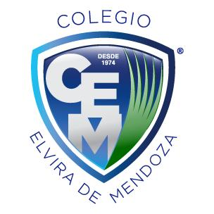

**Colegio Elvira de Mendoza**

**5to grado de Secundaria**

**Inglés**

**Guía 1**

I – Review (page 54)

II – Research on comparative and superlative form

III – Complete pages 56 -57 of the book

IV – Research on sequence words and while and when