**6th grade – science. 1st week.**

Oceans changing size.

Causes and consequences.

**6th grade – science. 2nd week.**

Earth's tectonics plates movement.

Causes, consequences and process.

**6th grade – science. 3rd week.**

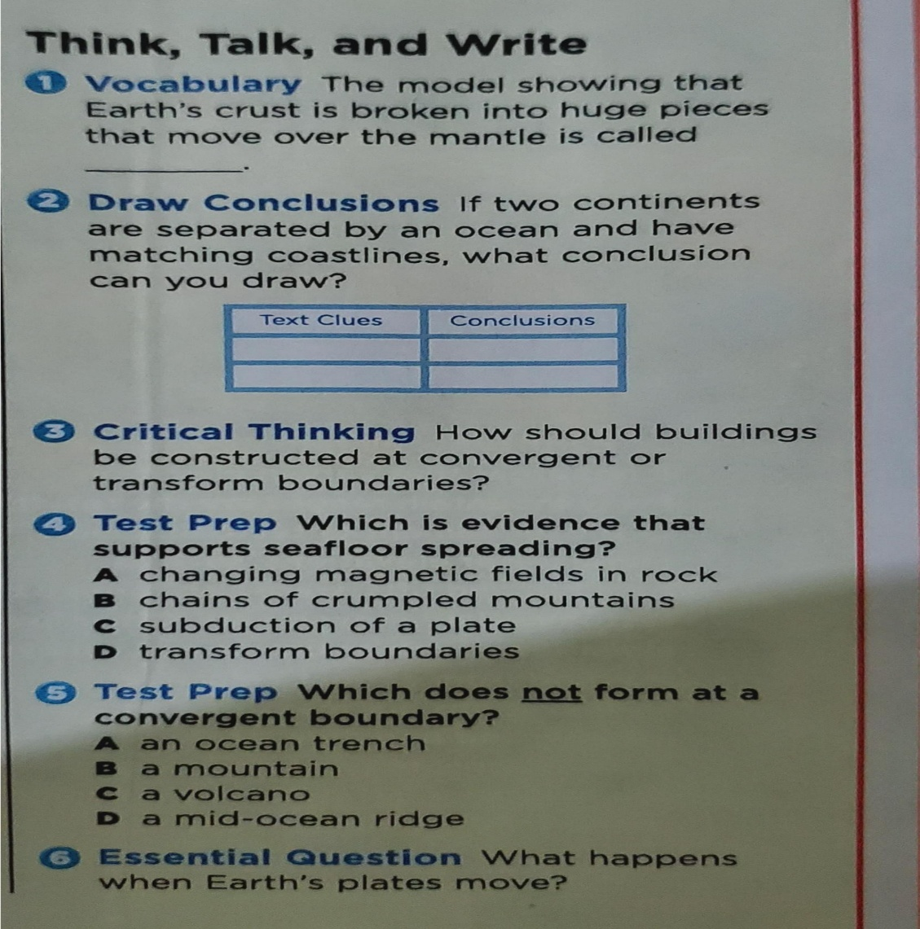Have students complete the questions about what we have been seeing.

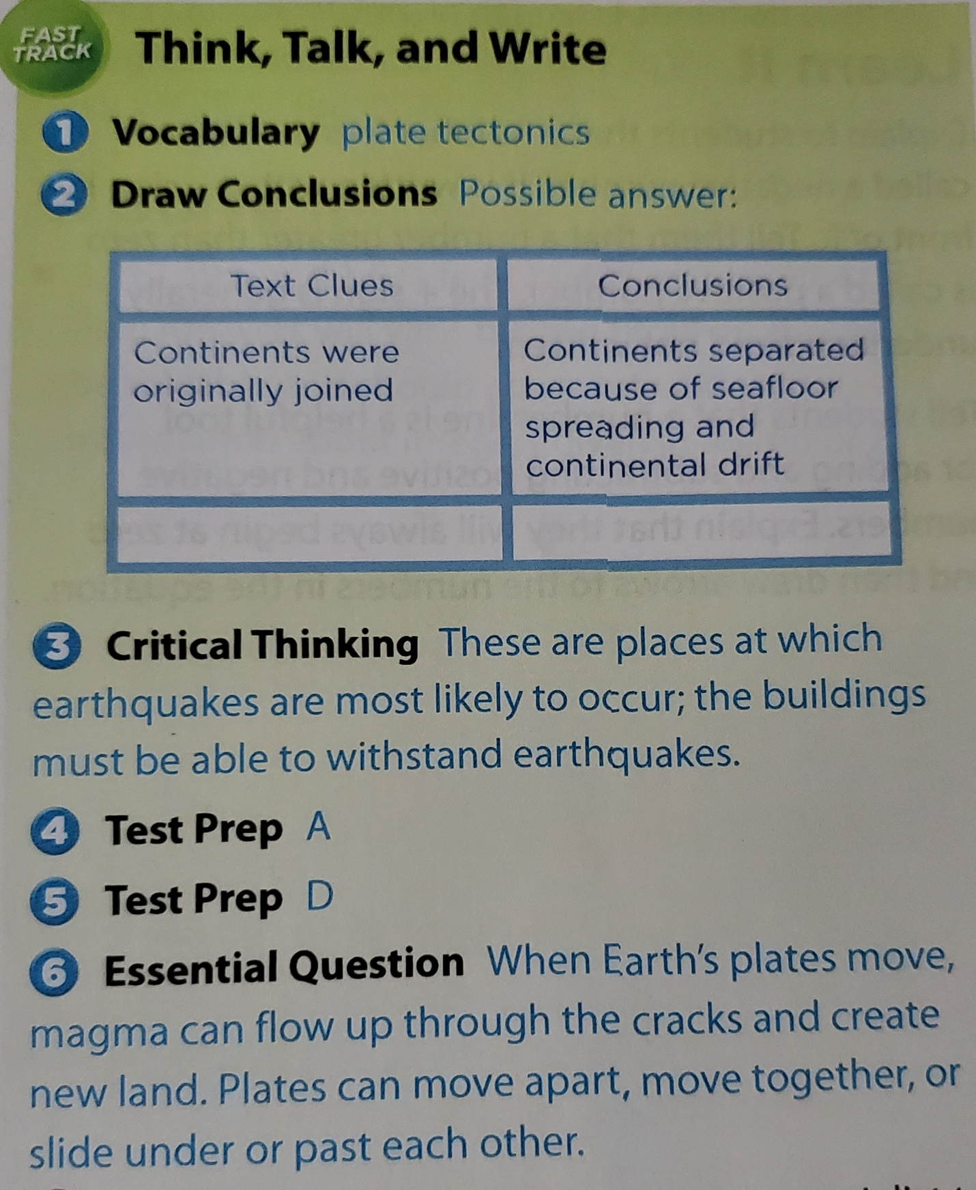**Answer sheet**.

**6th grade – social studies. 1st week.**

Most remarkable people of ancient Rome.

**6th grade – social studies. 2nd week.**

Most important places and events of ancient Rome.

**6th grade – social studies. 3rd week.**

How these events affect the modern society?

Students will have to write their thoughts and record themselves talking about it.

**6th grade – math. 1st week.**

Students will complete pages 56 and 57 of the practice book, which are practices about what we have been seeing in class.

**6th grade – math 2nd week.**

Look for the definitions and examples of the following concepts.

-dividend.

-divisor.

-equivalent fractions.

-greatest common fractions.

-prime number.

-quotient.

-reciprocals.

-simples form.

**6th grade – Math. 3rd week.**

Multiply fractions.

Students will go to page 59 of the practice book and complete this example of multiply fractions.

**6th grade – language arts. 1st week.**

Learn about folktales.

What does the word “Folktale" mean?

What are the most common folktale you’ve heard?

**6th grade – language arts. 2nd week.**

Students will read the folktale “the clever daughter in law”

Answer the questions:

-Why does the old man want his sons to marry?

-What gifts does the old man asked for?

-What gifts do you think the farm girl will have ready for the sisters?

**6Th grade – language arts. 3rd week.**

Read the passage “Chinese Lantern Festival".

Students will have to record themselves reading the passage and send it to the teacher.